**SCRUM MEETINGS**

**DAILY STAND-UP MEETING:**

A short daily meeting (usually 15 minutes) where the Scrum team quickly discusses progress, plans, and problems. It keeps everyone on the same page and helps identify obstacles early.

**Who attends:**

* Development Team
* Scrum Master
* Product Owner (optional, but can join)

**When it happens:**

* Every day, ideally at the same time and place.
* Usually done standing up to keep it short and focused.

**What is discussed:**  
Each team member answers **3 simple questions**:

1. **What did I do yesterday?** – Share completed work.
2. **What will I do today?** – Explain plans for the day.
3. **Is anything blocking me?** – Highlight any problems or obstacles.

**Benefits:**

* Keeps the team aligned.
* Detects issues early so they can be fixed quickly.
* Promotes accountability and transparency.
* Helps the team stay focused on Sprint goals.

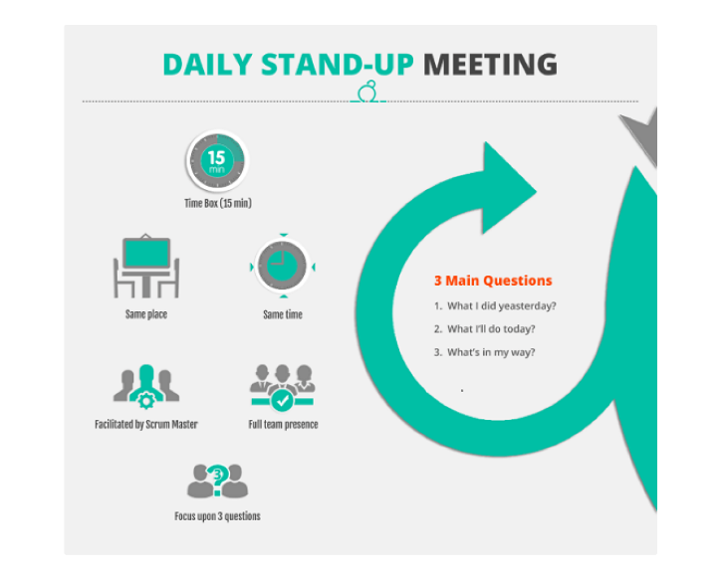

**PLANNING MEETING:**

A meeting at the start of a Sprint where the Scrum team decides **what work to do** and **how to do it** during the upcoming Sprint.

**Who attends:**

* Product Owner
* Scrum Master
* Development Team

**When it happens:**

* At the beginning of each Sprint (usually every 2–4 weeks).

**What is discussed:**

1. **What to do:**
   * The Product Owner explains priorities from the **Product Backlog**.
   * The team selects tasks they can complete in the Sprint.
2. **How to do it:**
   * Tasks are broken down into smaller steps.
   * The team estimates effort and plans work for the Sprint.

**Benefits:**

* Sets a clear focus for the Sprint.
* Helps the team understand priorities and plan work realistically.
* Encourages team collaboration and shared understanding.

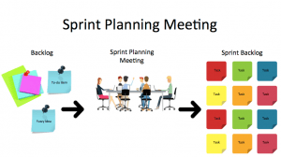

**RETROSPECTIVE MEETING:**

A meeting held at the end of a Sprint where the Scrum team reflects on **how they worked** and **how to improve** for the next Sprint.

**Who attends:**

* Development Team
* Scrum Master
* Product Owner (optional)

**When it happens:**

* At the end of each Sprint, after the Sprint Review.

**What is discussed:**  
The team answers questions like:

1. **What went well?** – Celebrate successes and things that worked.
2. **What didn’t go well?** – Identify problems or challenges faced.
3. **What can we improve?** – Decide on actions to work better next Sprint.

**Benefits:**

* Encourages continuous improvement.
* Builds team communication and trust.
* 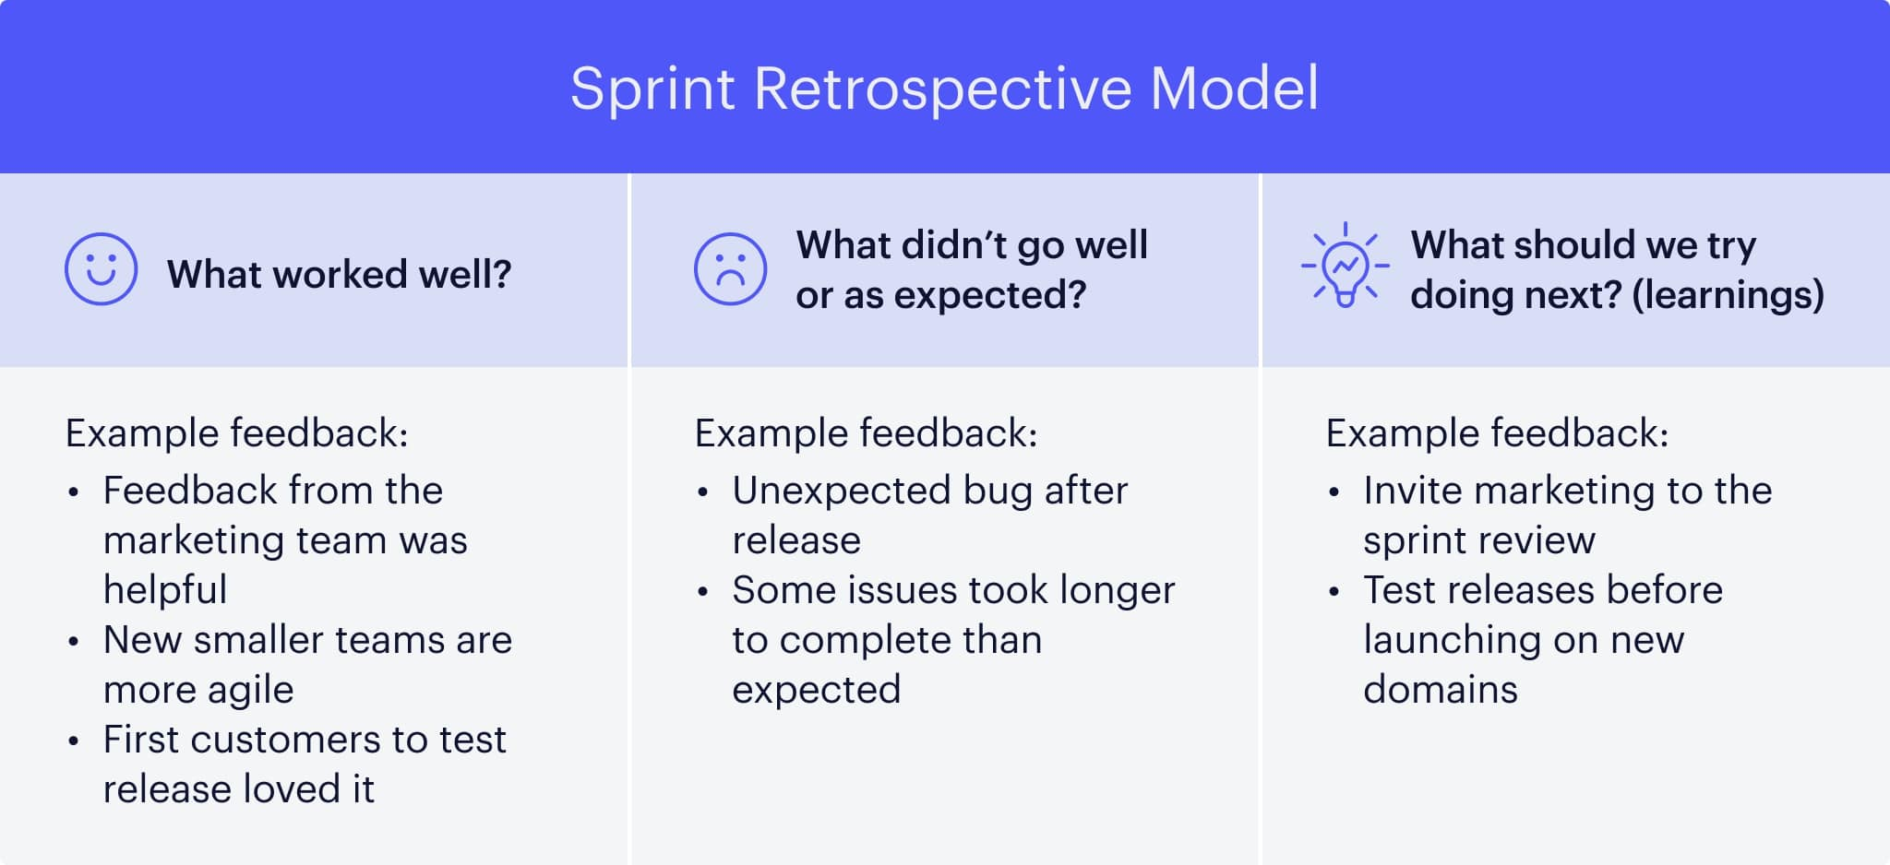Helps prevent recurring problems.